Penetration Testing with Sqlmap and Burp Suite

Ahmed Malik

Stockton University

**Introduction 3**

**Section 1: Lab Environment Setup 4**

Section 1.1: Victim Machine Configuration 4

Section 1.2: Attacker Machine Configuration 10

**Section 2: Attack Preparation 13**

Section 2.1: Victim Configuration 13

Section 2.2 Attacker Tool Preparation 20

Section 2.3: Connectivity Testing 21

**Section 3: The Attack and Results 24**

3.1 SQLi using sqlmap 24

3.2 Insecure Direct Object Reference (IDOR) 34

3.3 Cross-Site Scripting 36

**Conclusion 37**

**Appendix 38**

# Introduction

The purpose of this project was to explore how common web application vulnerabilities can be exploited in a controlled lab environment. Using two virtual machines, a Windows 10 victim running bWAPP and a Kali Linux attacker. I tested and documented attacks against SQL injection (SQLi), insecure direct object references (IDOR), and cross-site scripting (XSS). The goal wasn’t just to trigger these vulnerabilities, but to understand how attackers find them, how tools like Burp Suite and sqlmap can be used in real-world scenarios, and what kind of impact these issues can have. By walking through the setup, exploitation, and results step-by-step, this report shows how small misconfigurations and poor input handling can lead to serious security problems.

# 

# 

# Section 1: Lab Environment Setup

## Section 1.1: Victim Machine Configuration

The first step is to download Windows 10 to be our Victim

* Head over to <https://www.microsoft.com/en-us/software-download/windows10> and download the “Windows 10 installation media”
* 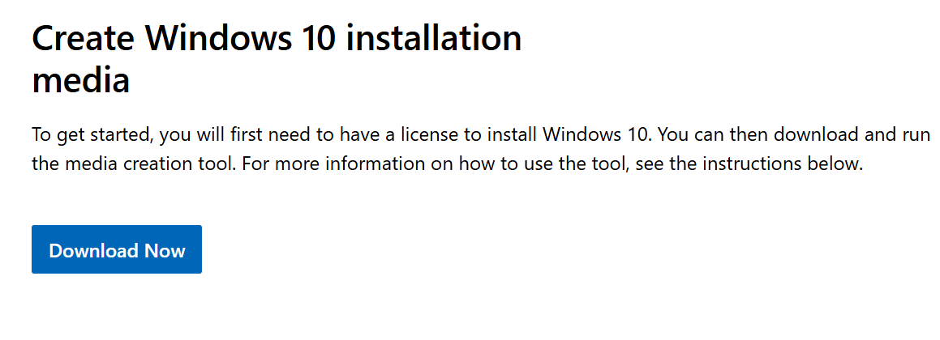
* It will download an executable file, double-click on it to begin the installation process
* 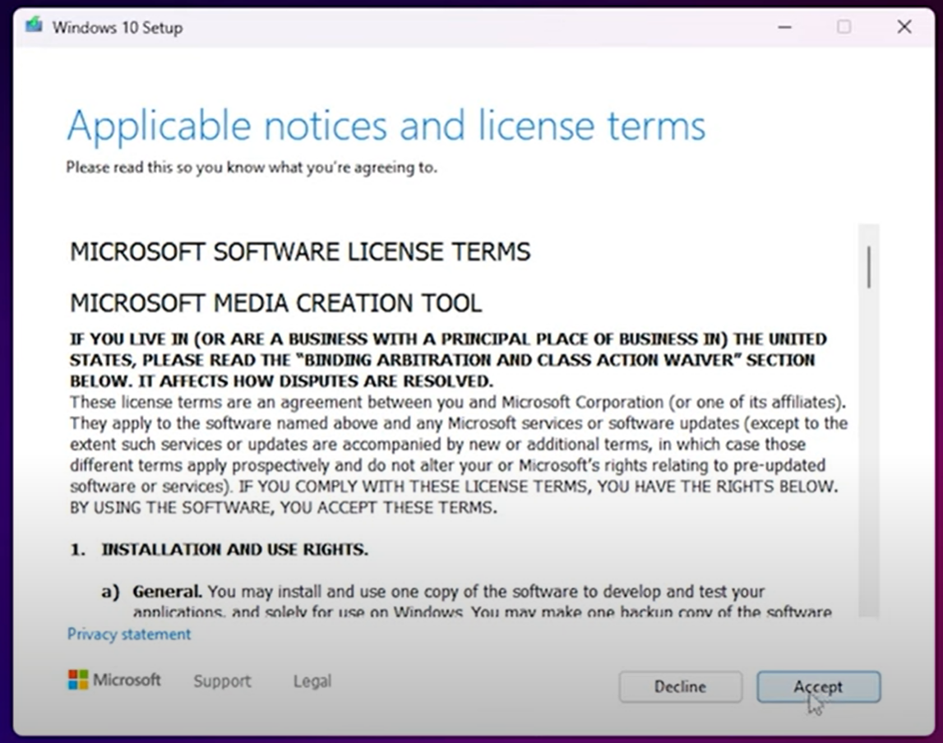 Click Accept to begin
* 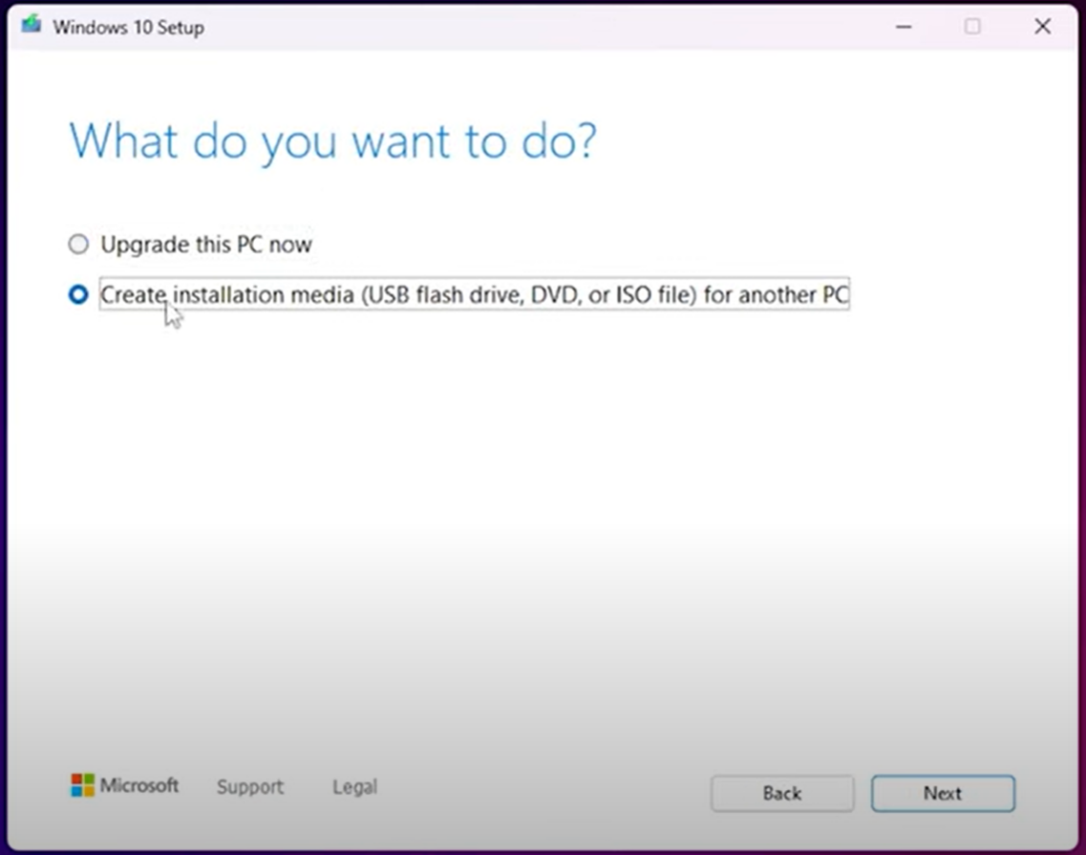 Make sure to select “**Create installation media**”
* Select your language, Edition to Windows 10, and Architecture to 64-bit (x64)
* 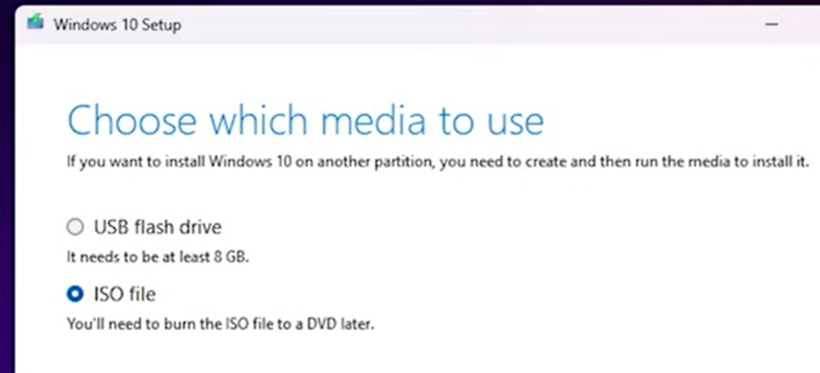Lastly, make sure to select “**ISO file,**” which allows us to use it for the virtual machine.
* Once your Windows 10 iso file is downloaded, we can move on to setting up the virtual machine environment
* Select New, your ISO Image, and skip the unattended install
* 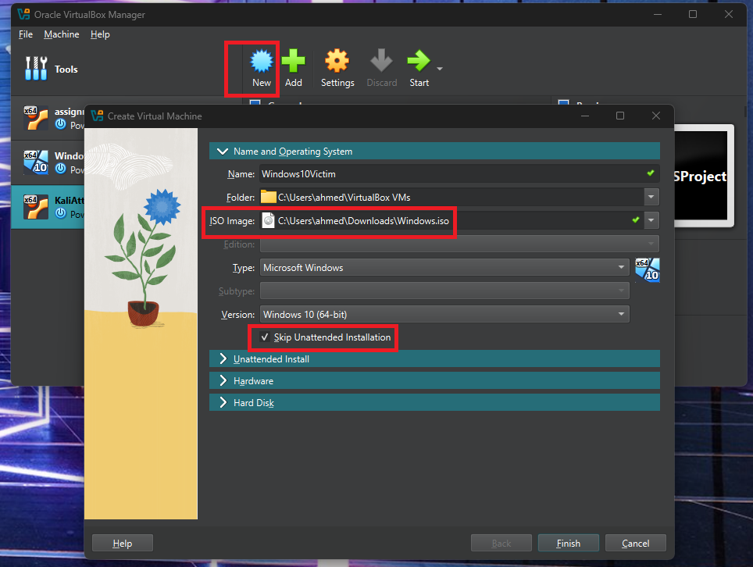
* 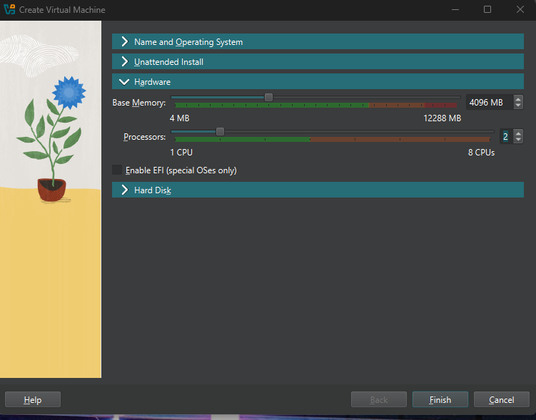 These should be the minimum settings for the Windows Machine
  + Base Memory: 4096 MB
  + Processors: 2 CPUs
* Set the hard disk to 50 GB and finish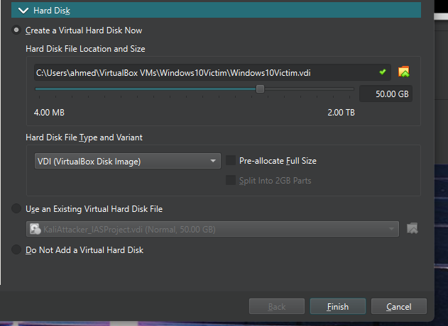
* Once finished, set clipboard to bidirectional, and we will set the network to **NAT** for now

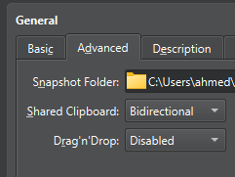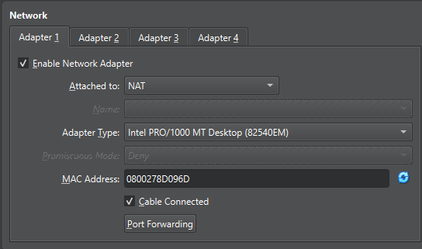

* Now we are ready to boot up the machine
* Booting up will prompt us with Windows Setup

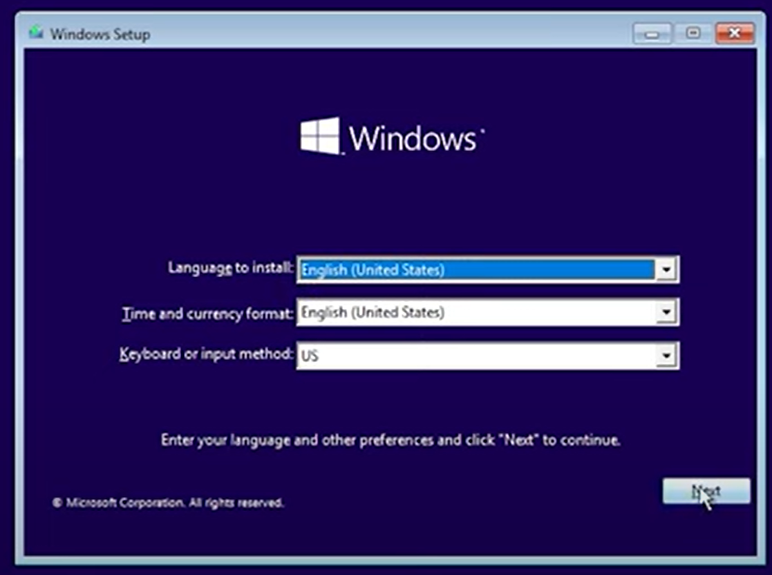

* 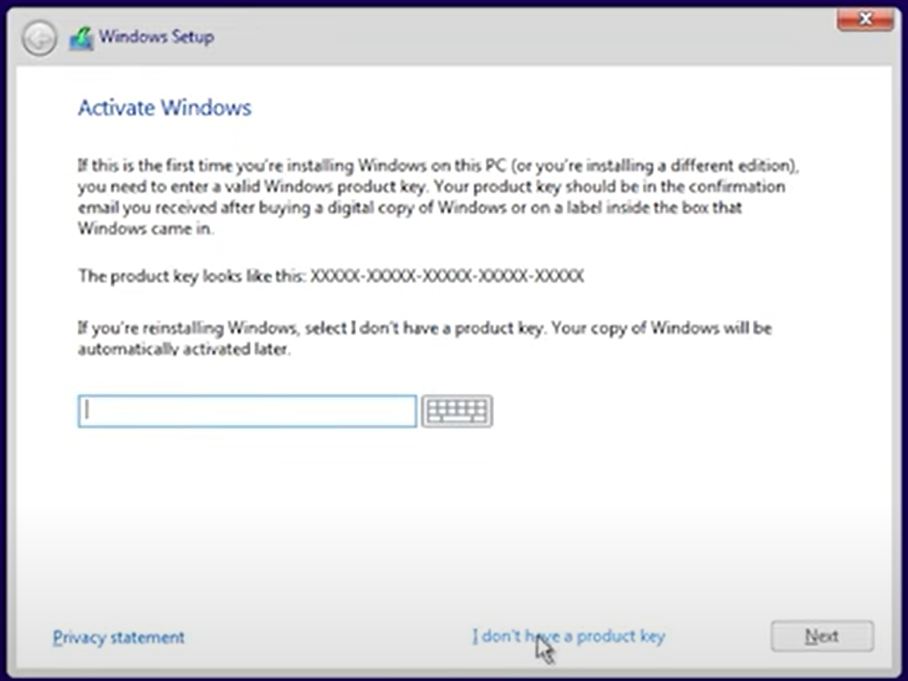 At this point, select “I don't have a product key”
* After this, it will prompt you to choose the edition of Windows 10, choose “Windows 10 Pro”
* Accept the notices and license terms
* Choose Custom Install

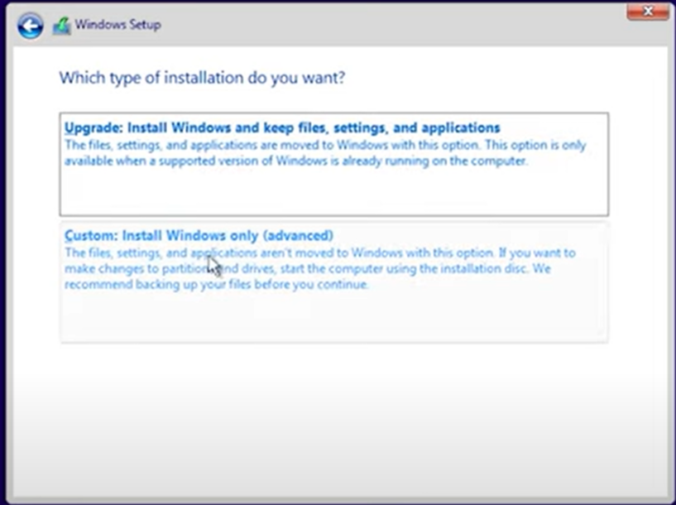

* Select the drive which we have set to 50 GB, then it will begin to copy and install files, and will automatically reboot the VM
* Once rebooted, we can complete the setup for Windows

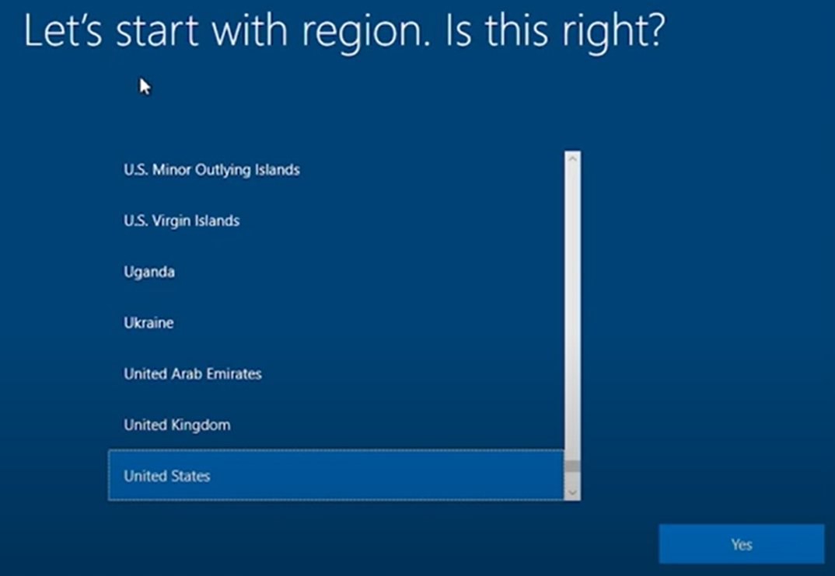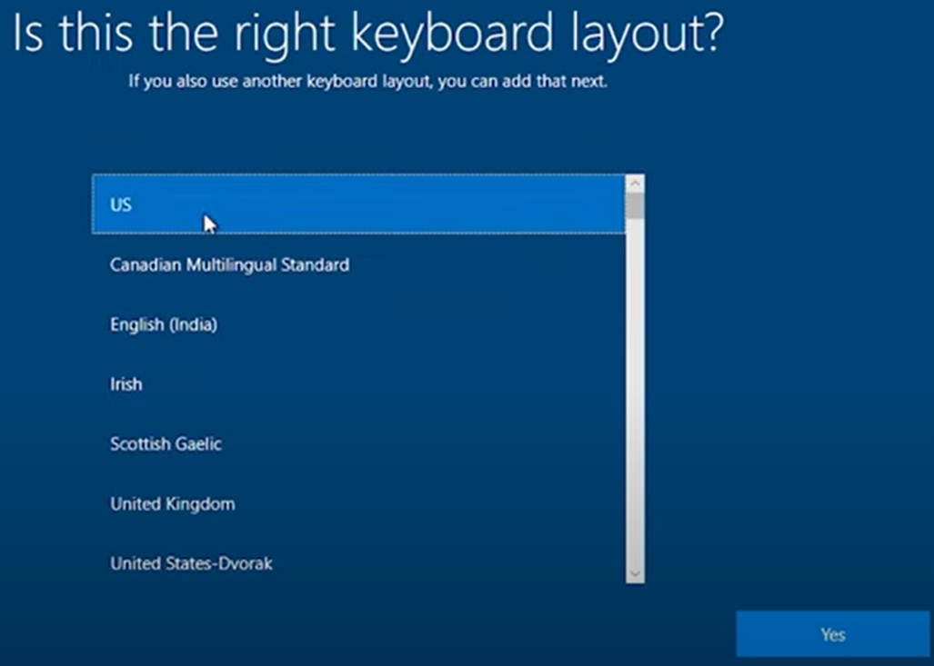

* Skip 2nd keyboard layout
* How would you like to set up: Set up for personal use
* Let’s add your account: Select “Offline account”
* 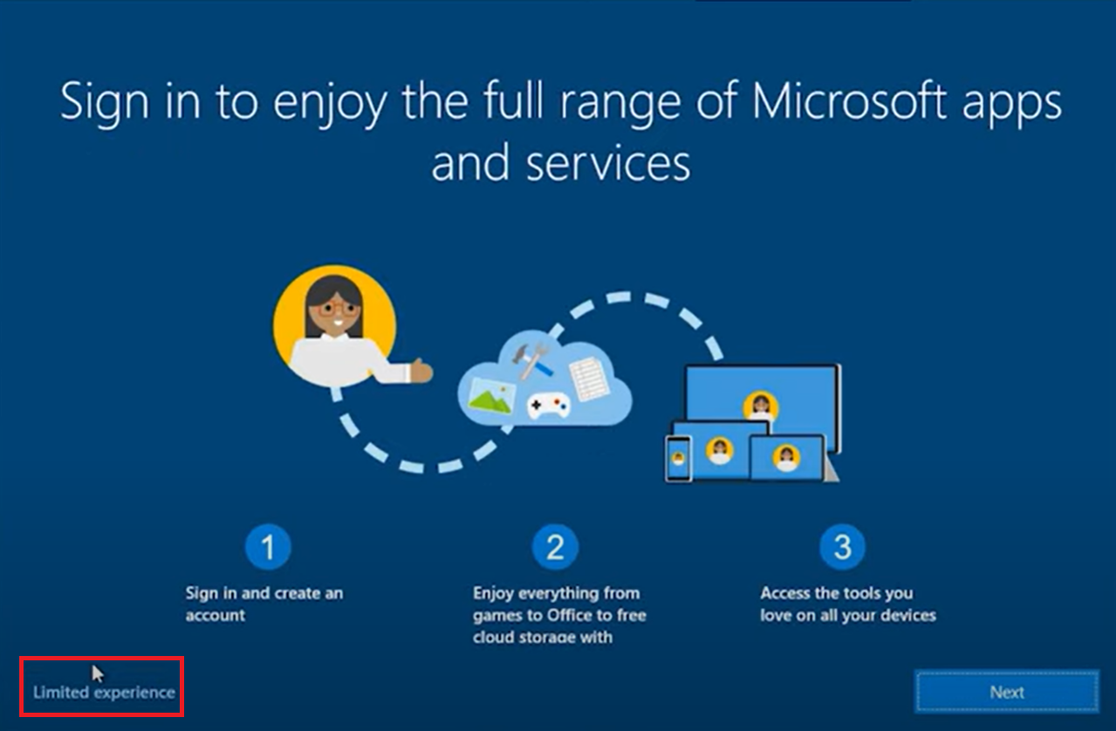 Select “Limited experience”
* After this:
  + Set a name for Windows
  + Set password
  + Choose security questions
* Always have access to your recent browsing data: Select “Not now”
* Accept privacy setting for the device
* Let’s customize your experience: Skip
* Let Cortana help you get things done: Select “Not now”

The Windows 10 Virtual Machine is now up and running

## Section 1.2: Attacker Machine Configuration

Now time to set up our Kali Linux machine

* Go to <https://www.kali.org/get-kali/#kali-platforms>
* Click “Installer Images” 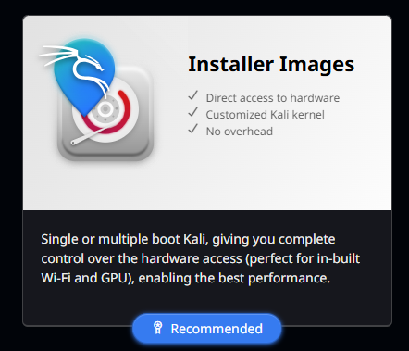
* Download the ISO file 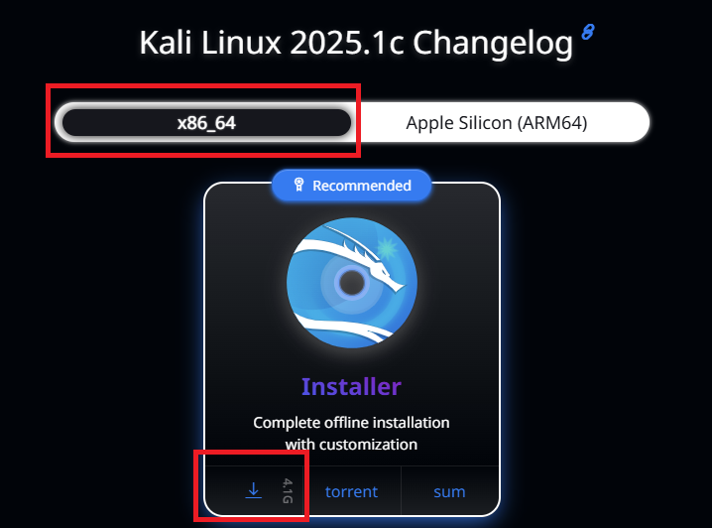
* Add the ISO image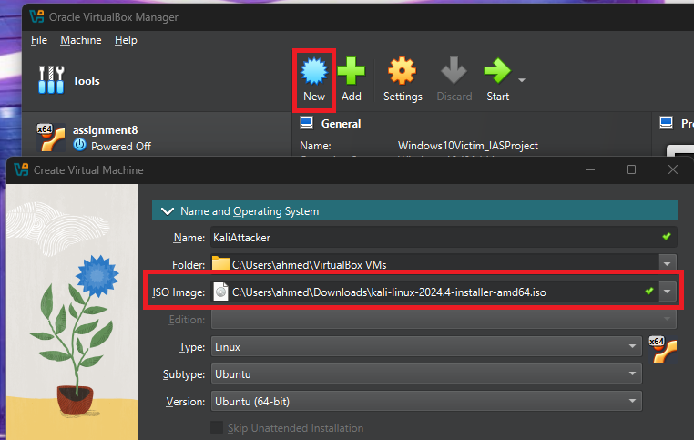
* Set the hardware and hard disk specifications:
  + 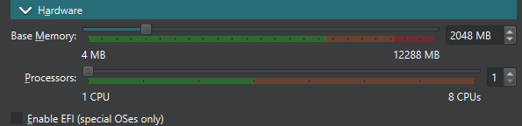
  + Set hardware to at least:
    - Base Memory: 2048 MB
    - Processors: 1 CPU
  + 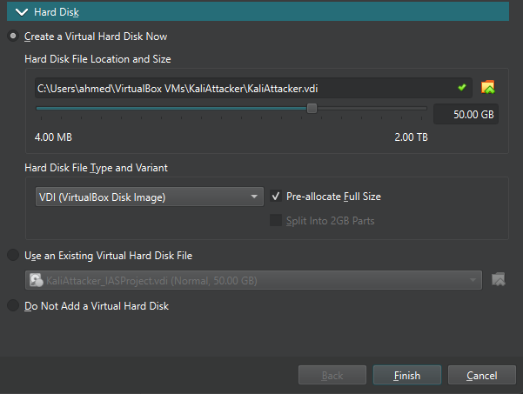
    - Check “Pre-allocate Full Size”
    - Disk Storage: 50 GB
* Keep Network as **NAT**. Now it’s ready to boot up
* Select: Graphical Install
  + Language (English), Location (United States), Keyboard (American English)
  + Hostname and Domain name
  + Real Name, Username, and Password (must remember)
  + Clock (Eastern)
  + Partition disks: use entire disk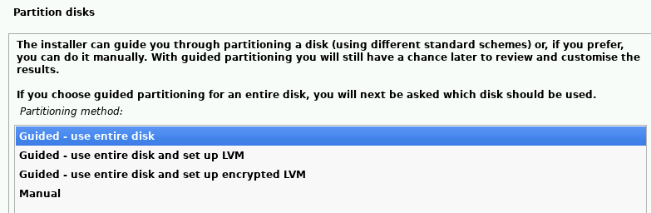
  + Click continue here 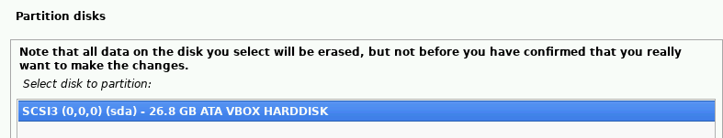
  + Partition all files in 1 partition 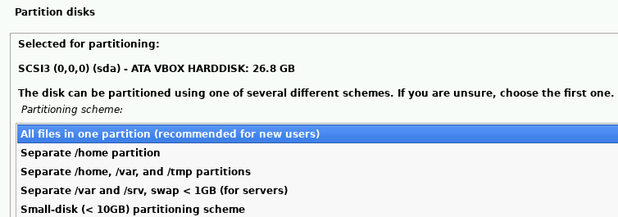
  + Finish partitioning and write changes to disk, click continue
  + Select Yes, then continue 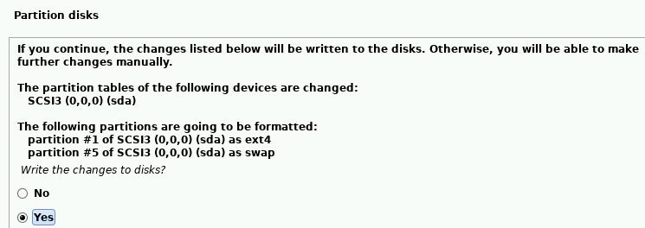
  + Software selection: keep default
  + Install the GRUB boot loader: Select Yes
  + Device for boot loader: /dva/sda {ata-VBOX…
* Finish the installation, Kali will automatically reboot

# Section 2: Attack Preparation

## Section 2.1: Victim Configuration

Make sure VM is set to **NAT** to begin

1st Step: Download XAMPP: <https://sourceforge.net/projects/xampp/files/XAMPP%20Windows/5.6.40/>

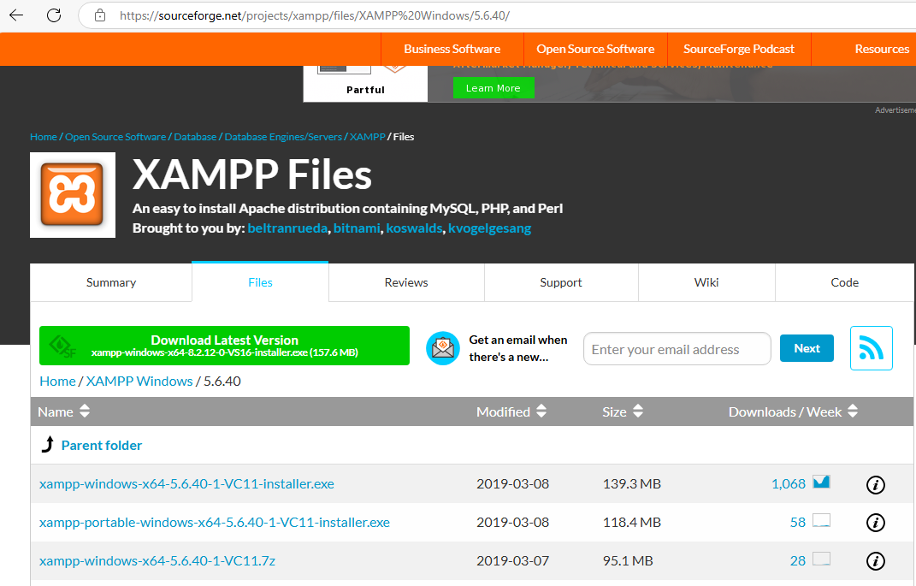

* Download: xampp-widows-x64 installer exe
* XAMPP must be version 5.6.40 or earlier to work *

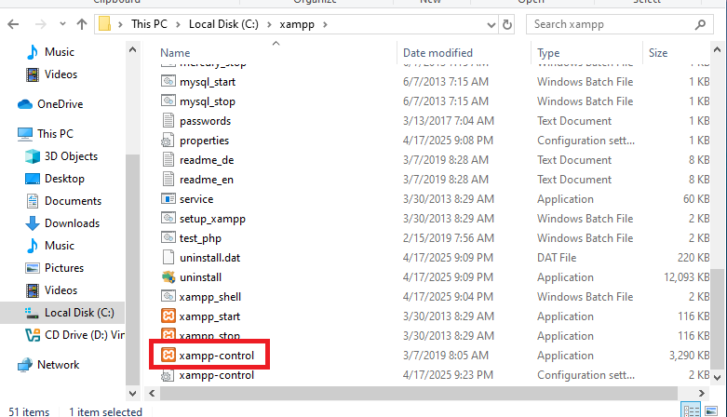

* Double click xampp-control to open the XAMPP control panel

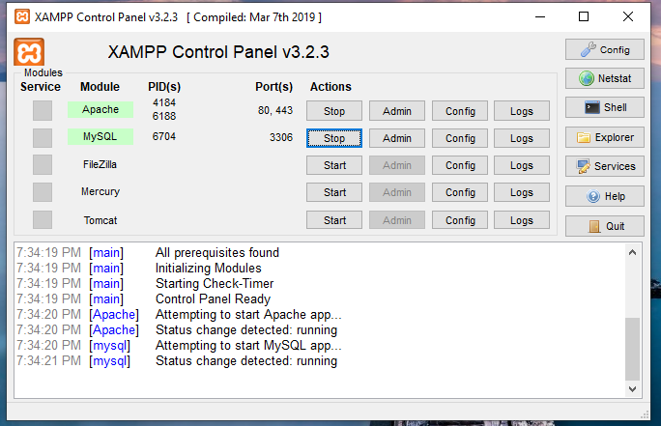

* Start Apache and MySQL modules and leave these running
  + These must be running for bWAPP to work

2nd Step: Download bWAPP

<https://sourceforge.net/projects/bwapp/files/bWAPP/bWAPPv2.2/>

* Windows might not let you download bWAPP due to virus detection 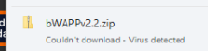
* To fix this:
  + Click Start: Search “Windows Security”
  + Click “Virus & threat protection”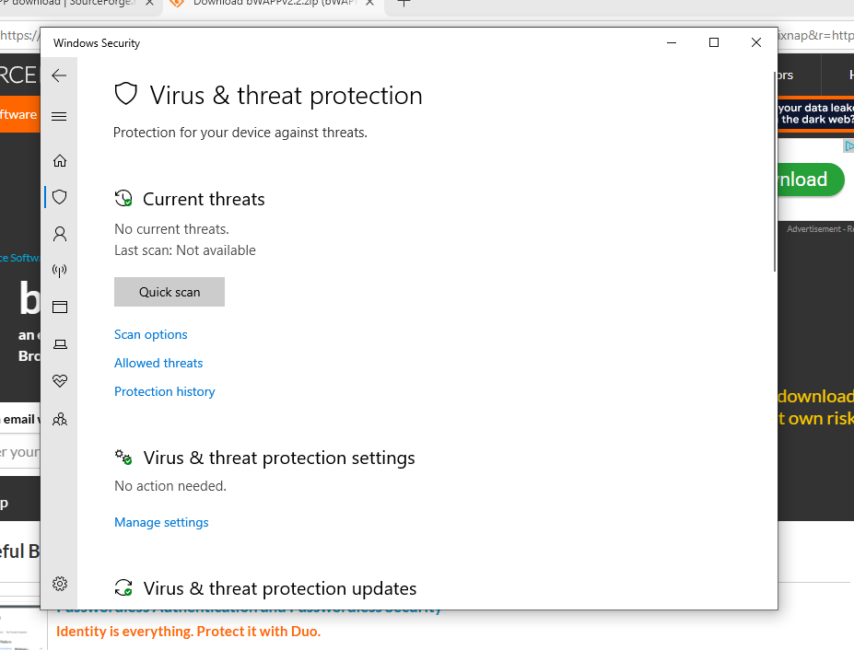
  + Click on Manage settings
  + Turn off Real-time protection

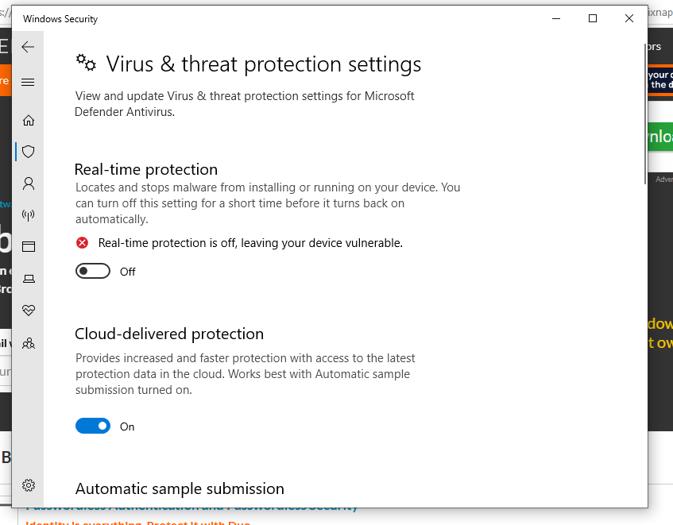

This can be turned back on after the download is complete

Make sure you are doing it on the Windows 10 VM and not your host machine

3rd Step: Locate and Extract the bWAPP ZIP File into C:\xampp\htdocs

4th Step: Launching bWAPP:

This part is crucial, installing bWAPP will not work right away with our setup *(visit the appendix to see more)

* We need to edit the install.php file in the bWAPP folder
  + 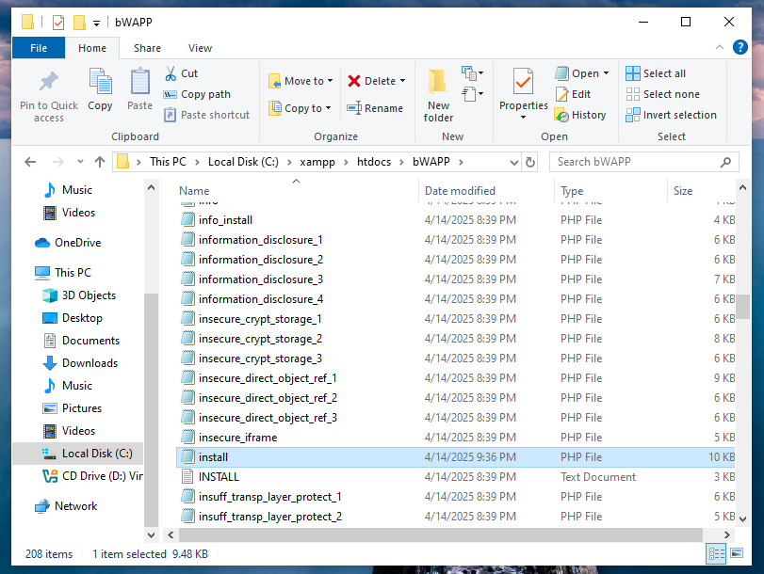
* Double click on the file to open it and add “**mysqli_report(MYSQLI_REPORT_OFF);**” in the same position as the picture below
  + 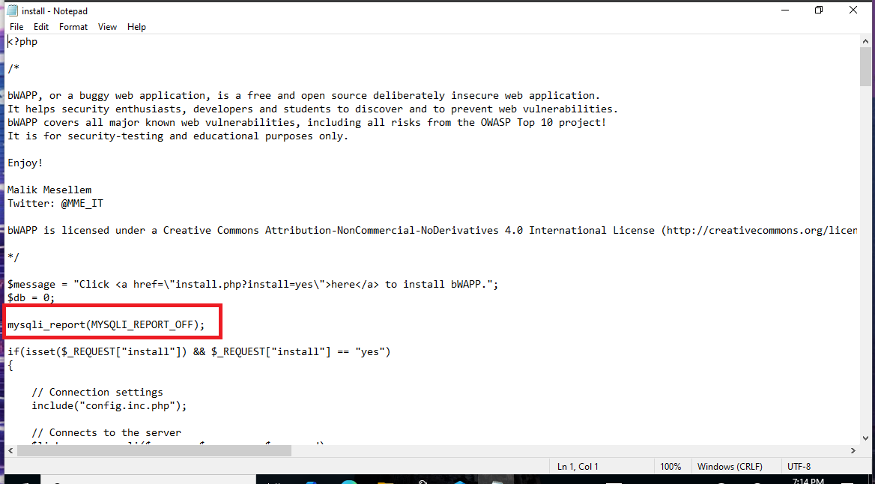
  + CTRL S before closing the file to save the changes
* Now visit <http://localhost/bWAPP/install.php>
* Click install
* Now we can create our account

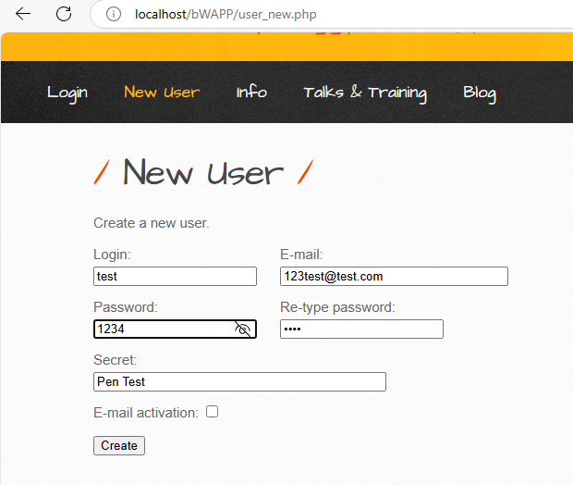

Once the account is created, power down the victim machine and set the network to **intnet**

Step 5: Turn the VM on again and set the static IP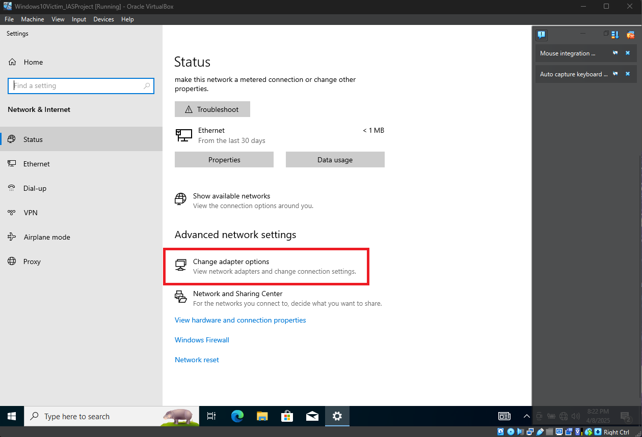

* Launch settings → Network & Internet → Status → Change Adapter Settings

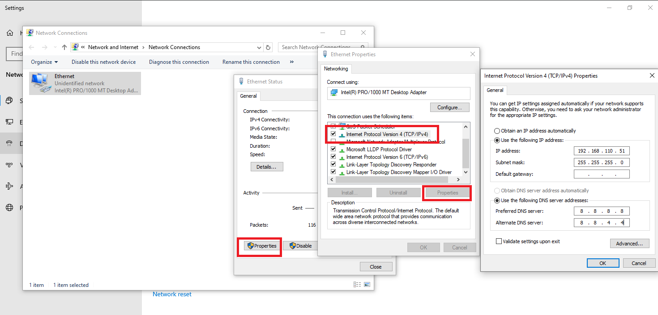

* Ethernet → Properties → IPv4 → Use following IP address
  + IP: 192.168.110.51
  + Subnet: 255.255.255.0
  + Preferred DNS: 8.8.8.8
  + Select “OK” when finished

## Section 2.2 Attacker Tool Preparation

Now we set up Kali so that it is ready to use for the attack

Open the terminal and update: 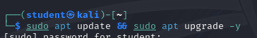

Installing sqlmap: 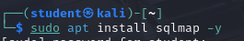

Checking for sqlmap and Burp Suite: 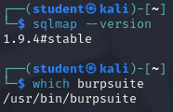

Now:

* Turn off poweroff Kali
* Change Adapter 1 to **intnet**: 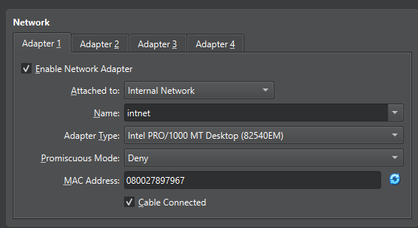
* Log back into Kali

Set the static IP:

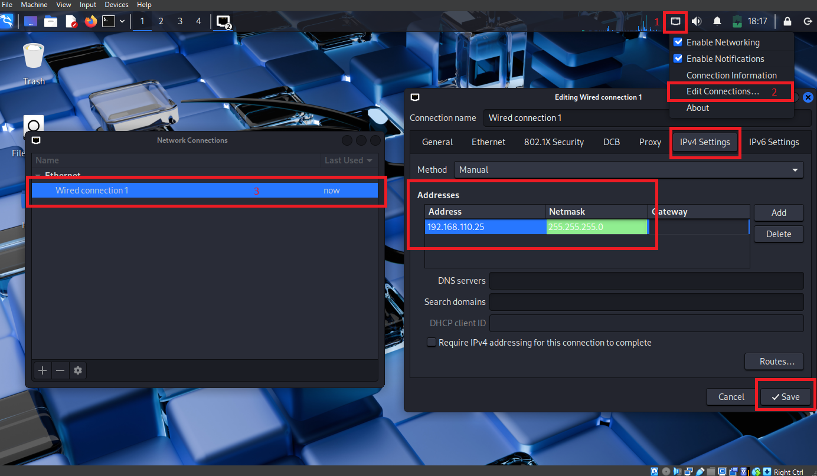

1. Right-click the Network button in the top right corner
2. Click on edit connections
3. Click “Wired connection 1”
4. Select ‘IPv$ Settings”
5. Input the static IP and Netmask
   1. IP: 192.168.110.25
   2. Netmask: 255.255.255.0
6. Save

## Section 2.3: Connectivity Testing

To test the connectivity of the machines, we have to first enable pinging on the Windows machine

1. Press ‘Windows Key + R’ and type: wf.msc (This opens Windows Defender Firewall)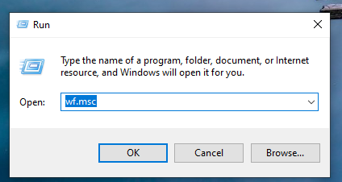
2. Click on “Inbound Rules” → “New Rule..” → ‘Custom”

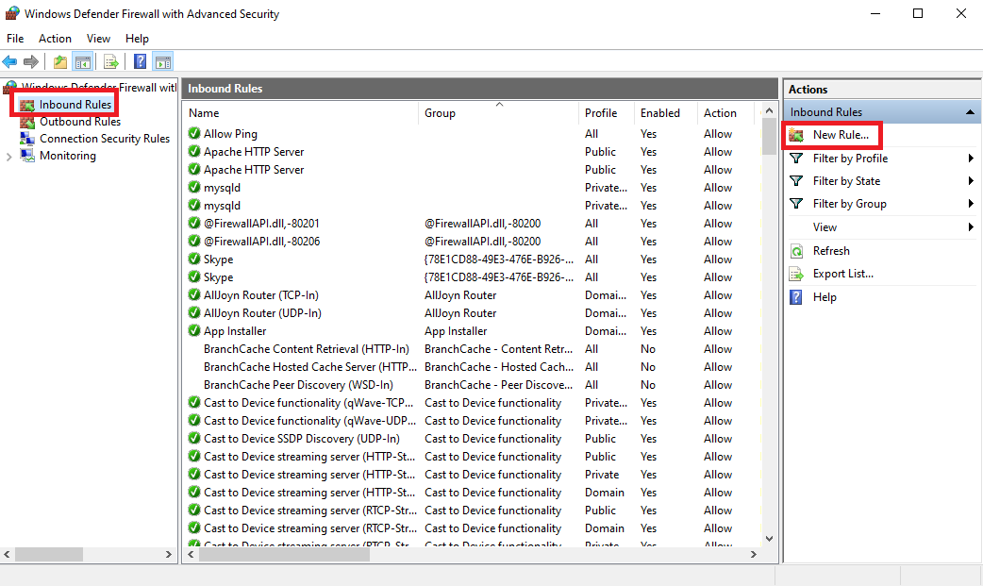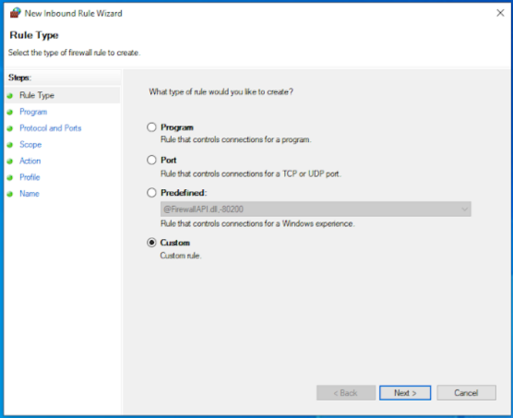

1. Program: All programs
2. Protocol and Ports

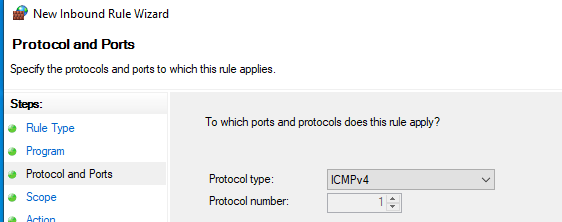

1. Scope: Allow for any IP addresses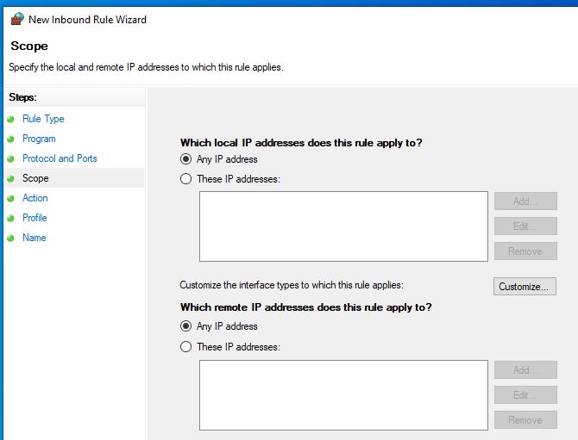
2. Action: Allow the connection
3. Profile: Check Domain, Private, and Public 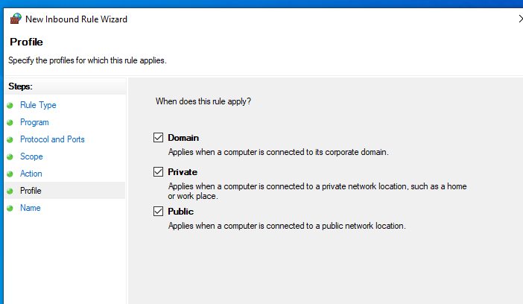
4. Name: Allow Ping

Now, when we test the connectivity, we get:

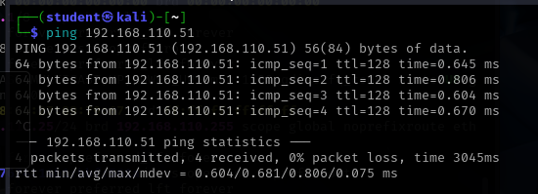

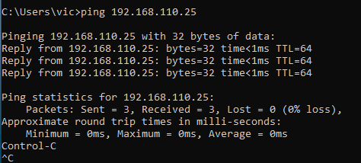

Both machines are now happily pinging each other, meaning we now know can communicate with each other and we can move on to the attack.

# Section 3: The Attack and Results

## 3.1 SQLi using sqlmap

Log in to bWAPP on Windows with the account we made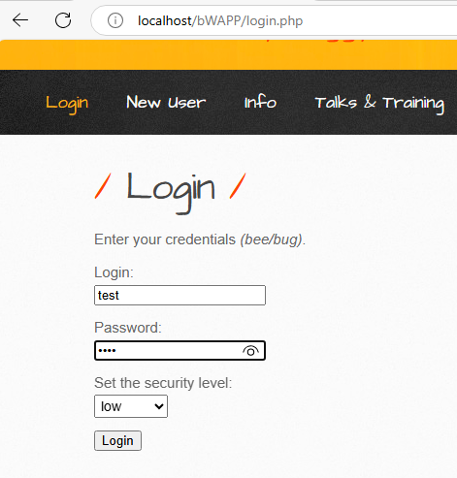

Now, on the Kali machine, open the browser and visit: <http://192.168.110.51/bWAPP/user_new.php>

Create the account here

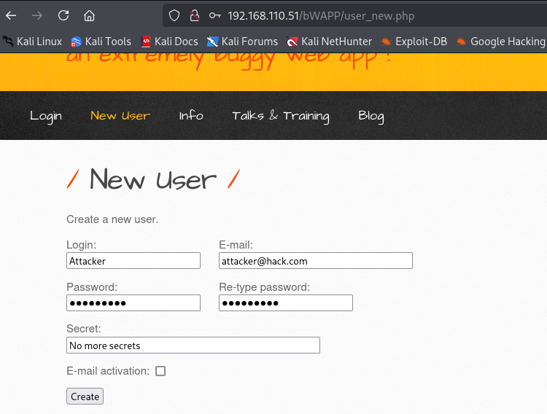

Now go to the Login page and log into our account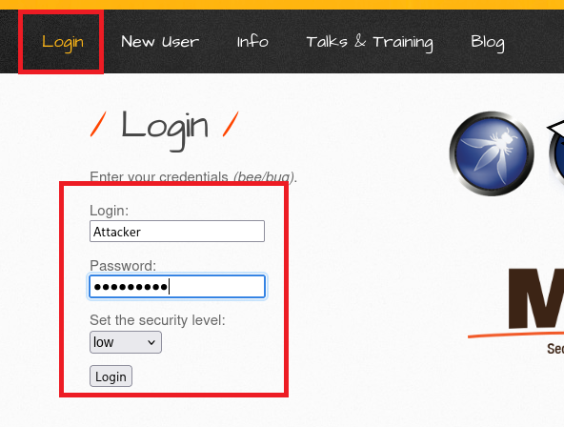

Once we are in, we do SQLi through various different attack vectors, but for this example, we will use POST. Click “Hack” to start the process.

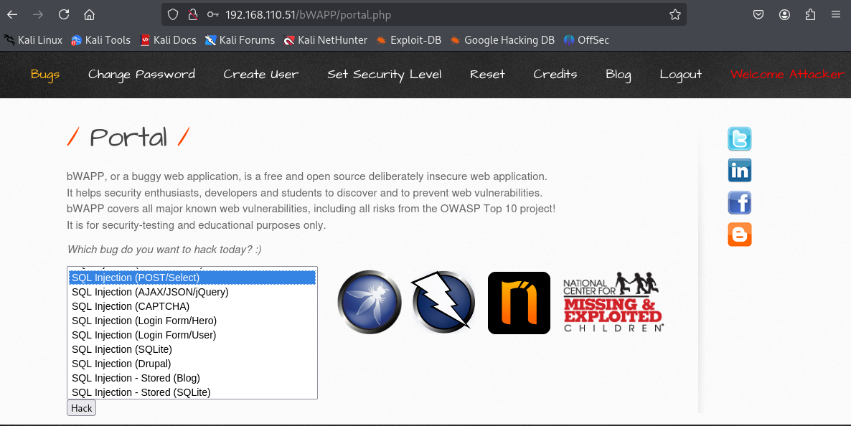

After clicking hack, it will open this page: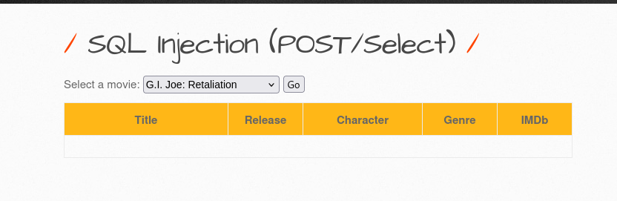

Click the “Go” button to see how the websites' Select function operates: 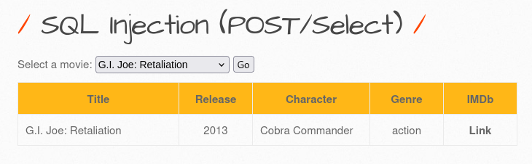

Now, we are ready to attack

Step 1: Open Burp Suite using the terminal  
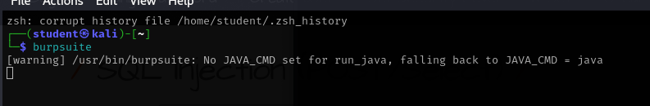

* Ignore the warning, it doesn’t affect anything, and we can still use Burp Suite just fine

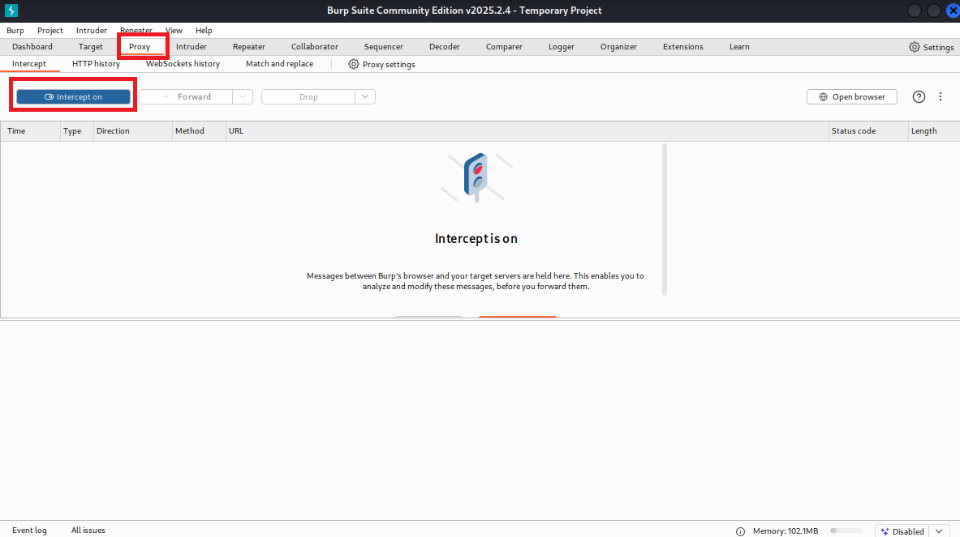

* With Burp Suite open, select the “Proxy” tab, and turn Intercept On
* Now go back to your browser, and for Burp Suite to intercept the HTTP request, we will need to edit the Network settings of our browser
  + 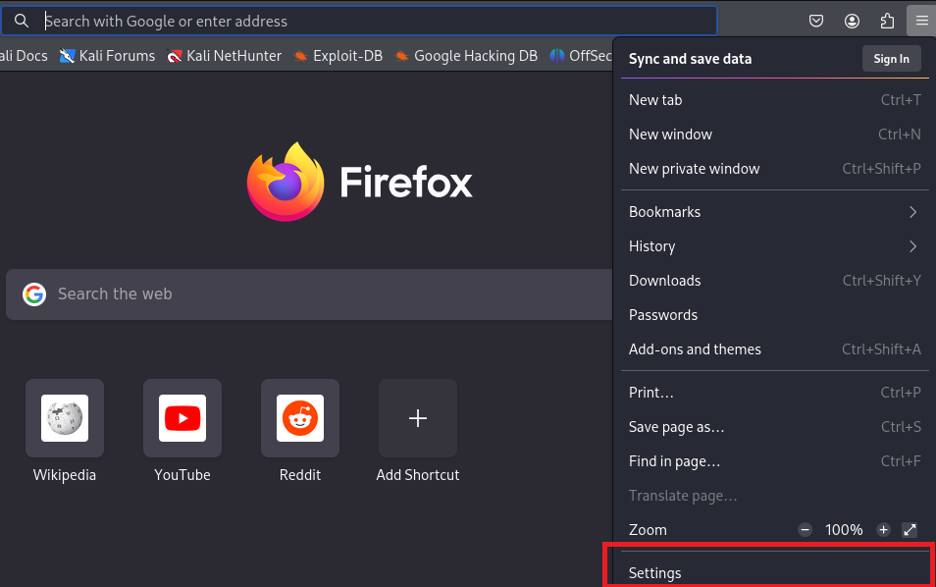
  + 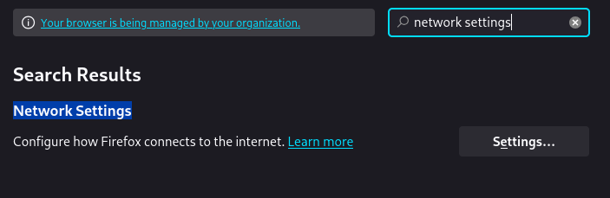
  + 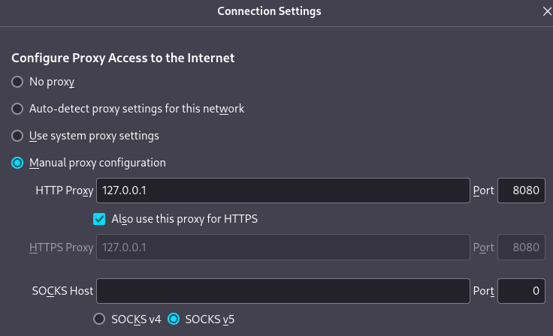
    - Switch Proxy to manual and set it to: 127.0.0.1 and the port to: 8080
  + 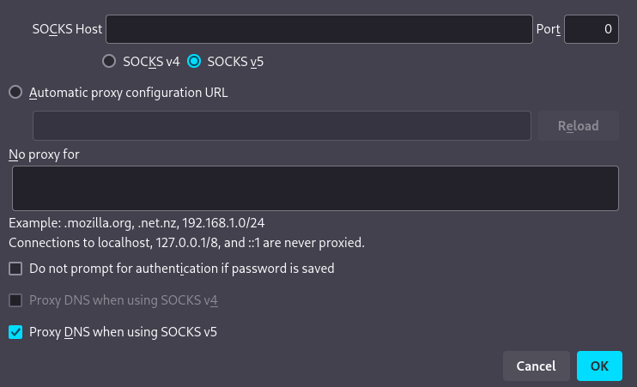
    - Keep all other settings the same, and click “ok”
* Now, going back to bWAPP on Kali, click the “Go” button to select a movie again.

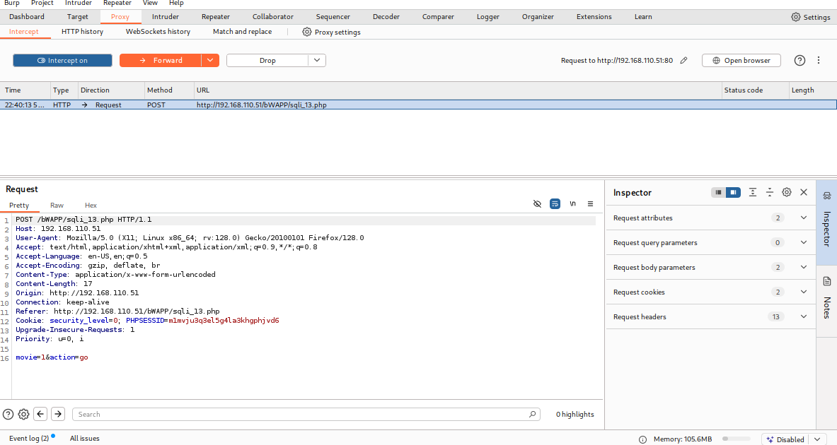

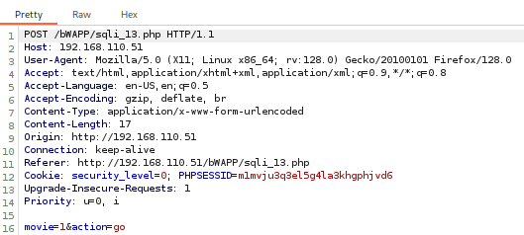*A closer look*

* Burp Suite has captured the HTTP Request when you clicked “Go”
* Right-click anywhere on the request and select “Save item”
  + 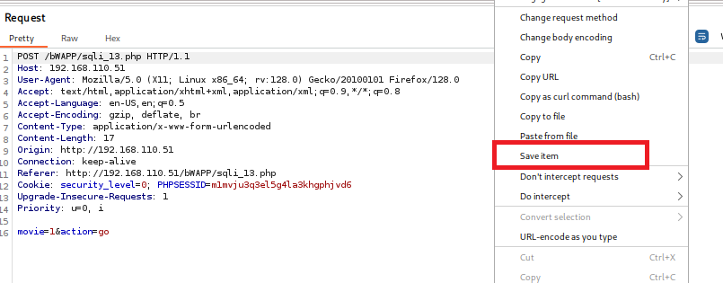
* Save it as “sqli13post.txt”
  + 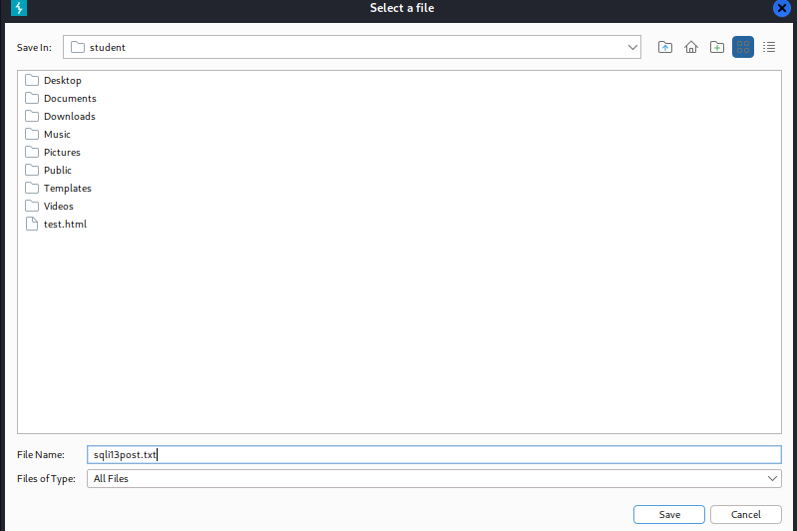
* Now open up a new terminal and type in the following command
* The first thing we need to see is what databases are being used by bWAPP

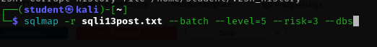

* **-r sqli13post.txt:** loads the HTTP request captured from Burp Suite.
* **- -batch:** allows sqlmap to run non-interactively, using default answers
* **- -level=5:** expands testing to include more techniques
* **- -risk=3:** allows potentially more dangerous payloads
* **- -dbs:** instructs sqlmap to enumerate all available databases

The result is shown below

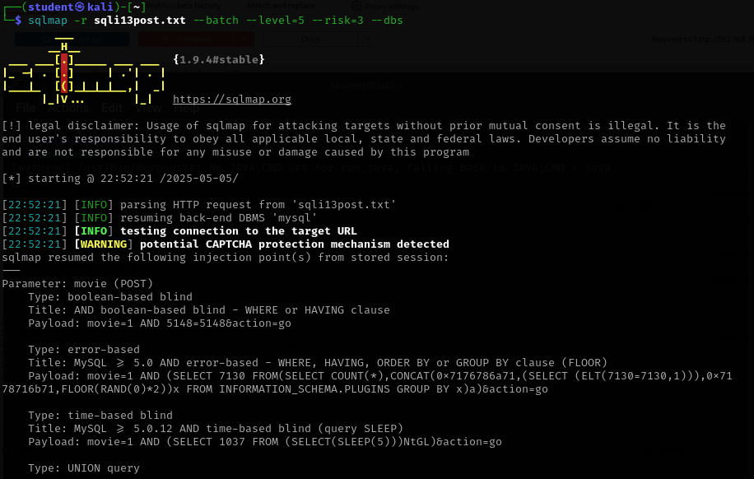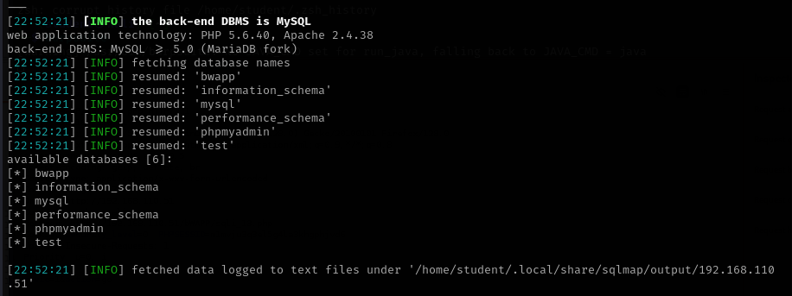

* Taking a look at the results, we can see the available databases. From this, we can pick a database to dive deeper. Here we can choose the bwapp database, assuming that it holds all the data for bwapp accounts.
* To get the tables, type in this command:



* **- -tables:** This tells sqlmap to enumerate and list all the tables inside the specified database
* **-D bWAPP:** Specifies the target database by name, in this case bWAPP, so sqlmap knows where to look for the tables.

Which gives this result:

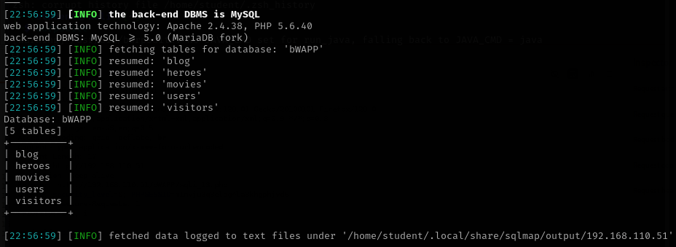

* Here we can recognize many different tables, including the **users** table. Now let’s extract data from this table
* To get the users, type in this command:



* **- -dump:** Dumps the actual contents of the specified table, such as rows and columns
* **-T users:** Specifies the exact table to target (users in this case) within the selected database (bWAPP).

Which results in:

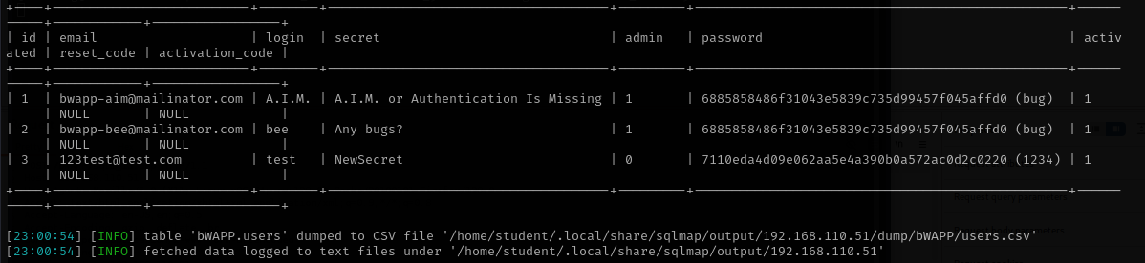

* From here, we can see all the usernames, passwords, secrets, and admin accounts.

At this point in our SQLi attack, we can now access admin accounts and the account we created on the Windows 10 machine

Admin 1

* Username: A.I.M.
* Password: bug

Admin 2

* Username: bee
* Password: bug

Windows 10 victim

* Username: test
* Password: 1234

We have successfully done a SQLi attack. This information gives us full ownership of the website as an admin as well as access to all other accounts. Now let’s take this a step further

## 3.2 Insecure Direct Object Reference (IDOR)

Using Burp Suite, we can go ahead and change the values of these fields. That means we could change the secret of an account remotely using bWAPP’s insecure direct object reference.

* Now we target the “Reset Secret” functionality for testing.

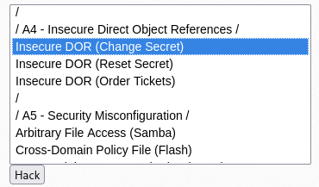

* Having Intercept turned on, simply click the “Change” button without typing anything in

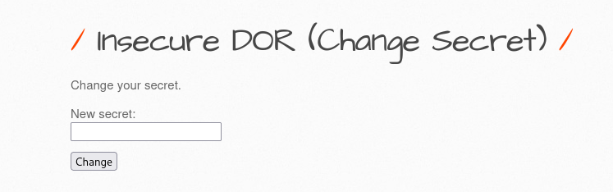

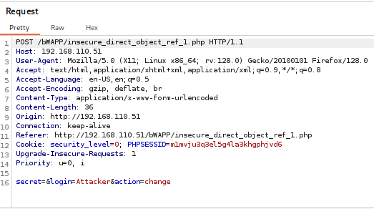

* This will be the resulting HTTP request. We can change these fields to match the victim account



Forward the request in Burp Suite to execute the modification.

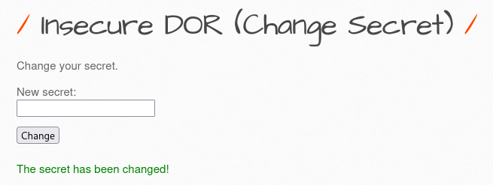

* Now, as you see, we successfully changed the secret, but let us run our sqlmap command again to make sure



* **- -fresh-queries:** Forces sqlmap to ignore any previously cached data from earlier runs and issue new, real-time requests to the target.

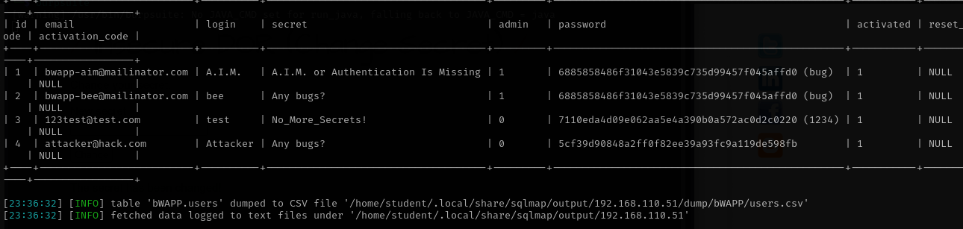

Now we can clearly see that because of bWAPP’s IDOR vulnerability, we were able to successfully change the victim's secret

## 3.3 Cross-Site Scripting

Lastly, we can take this attack one step further. Let’s do a real-time attack on the Windows machine using Burp Suite.

* Open the Cross-Site Scripting - Stored (Blog) on both the attacker and victim machines

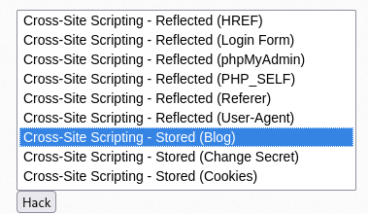

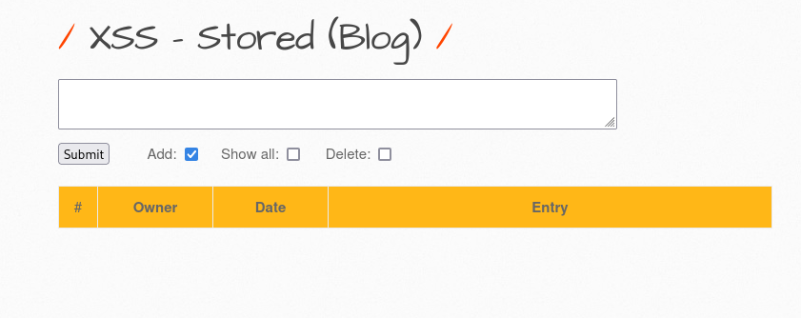

* Turning intercept on, click “Submit”

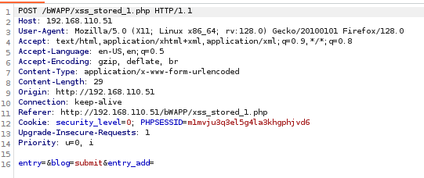

* With this HTTP request, we will change it to



entry=<script>alert("Security Alert: Please visit https://fix-account.example.com to resolve an issue with your account.");</script>&blog=submit&entry_add=

* Now, click forward on Burp Suite to send the request through
* Then, right after clicking forward, try to submit a blog post on the Victim machine

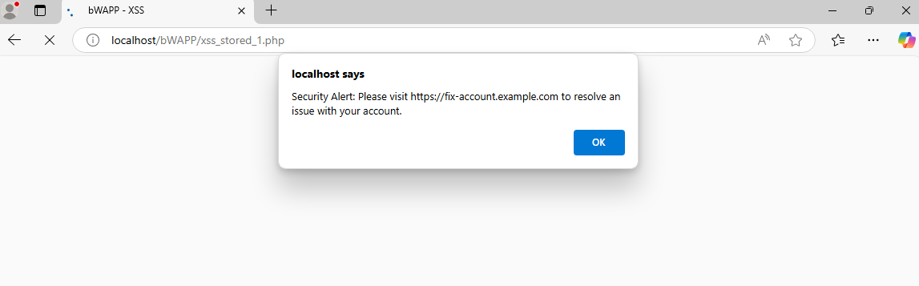

* The victim machine displays the phishing message as intended.

This demonstrated a successful stored XSS phishing payload delivered through Burp Suite.

# Conclusion

This project demonstrated how attackers can identify and exploit common web vulnerabilities using freely available tools in a lab setting. Starting with SQL injection, I used sqlmap and Burp Suite to enumerate databases and extract user data, highlighting how backend systems can be exposed through weak input validation. Then, through insecure direct object references (IDOR), I showed how changing a simple parameter in Burp Suite could alter data belonging to another user, an example of broken access control in action. Finally, I crafted a stored XSS payload to simulate a phishing attack, proving how unvalidated input can persist across sessions and be weaponized against unsuspecting users. Together, these attacks reflect the kinds of mistakes that developers often overlook and how attackers can chain basic vulnerabilities into serious compromises.

# Appendix

**bWAPP Difficulties**

When trying to install bWAPP on <http://localhost/bWAPP/install.php>, the first difficulty arose.

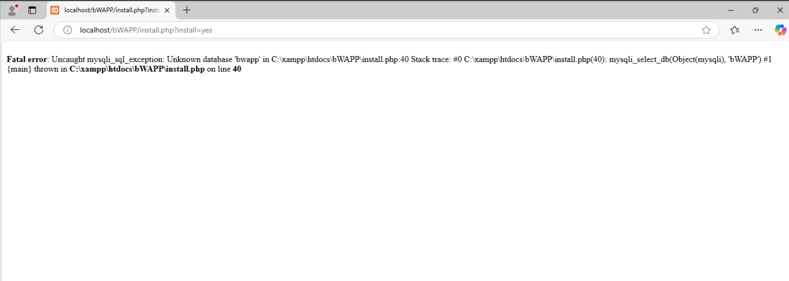

Clicking install would result in this message, saying that the bWAPP database did not exist. My next step was to manually go into the database via <http://localhost/phpmyadmin> and add a database named bWAPP. My thoughts were that something with the initialization of the program was faulty, so maybe creating the bWAPP database for the program could help it run, but then, when I tried to install it again, I got:

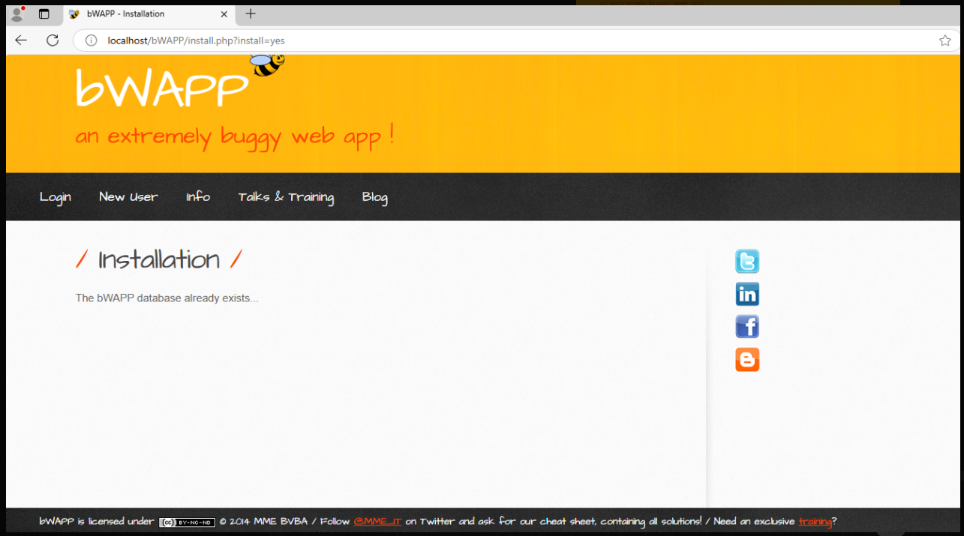

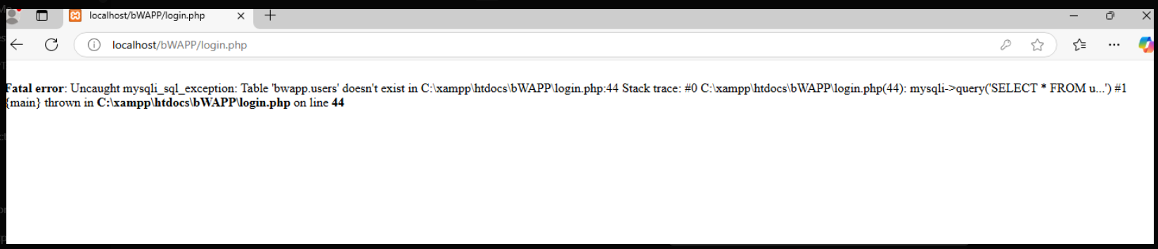

At this point, I didn’t know what to do. Luckily, a YouTube video I found had a similar problem with the database not being found and not initializing correctly.

Source:<https://www.youtube.com/watch?v=F-JQfQU3_mg&ab_channel=HamzaAvvan%28midnight%29>

This video also explained why it didn’t work because of an unhandled exception being thrown, so the line of code we added to the install.php file was to disable that exception.

**XAMPP Difficulties**

Originally, I had installed the newest version of XAMPP, version 8.2.12. However, after logging into bWAPP and trying to hack the first vulnerability I saw, this error would pop up

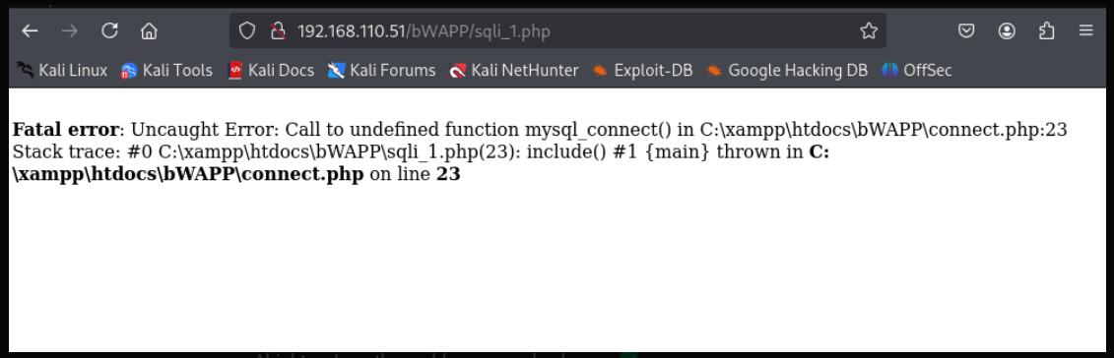

Right here it says “Call to undefined function mysql_connect().” This meant that the Windows 10 VM is using a newer version of PHP that does not support mysql_connect() anymore. Mysql_connect() was removed in PHP 7.0 and up. Modern PHP uses mysqli_connect(). So to get around this, instead of editing bWAPPs code to replace mysql_connect() with mysqli_connect(), I did the easier option, which was to downgrade our XAMPP to an older version. Specifically, version 5.6.40 which solved the problem.

**Pinging Windows**

At first, pinging Windows from Kali would not work because of the fact that Windows 10 Firewall blocks ICMP Echo Requests, which is the type of request pinging uses. So this was the reason we had to create a rule to bypass this firewall mechanism.

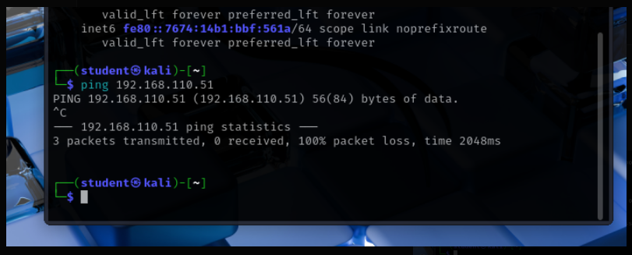

**Sqlmap Difficulties**

The original plan was to use sqlmap by itself and then introduce Burp Suite afterward to help sqlmap and do more attacks altogether. This plan didn’t fall into fruition due to sqlmap getting increasingly difficult to work with under our conditions. This was my methodology before implementing Burp Suite:

* Used the (GET/Search) as my attack vector
* Had to get the cookie manually by inspecting the web page:

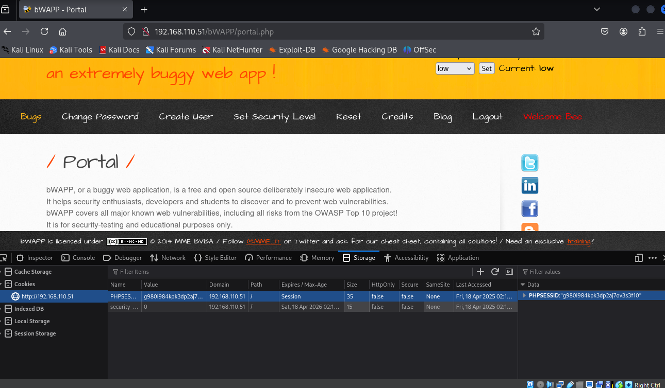

* This was my first attempt at getting the databases:

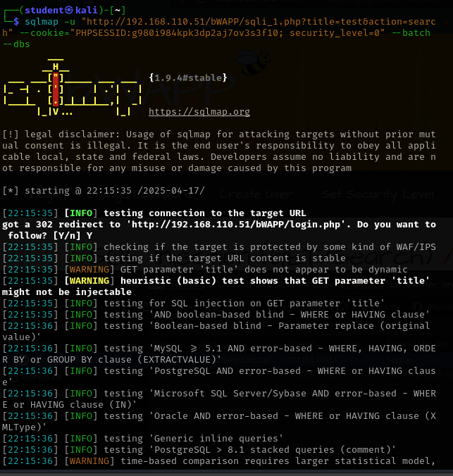

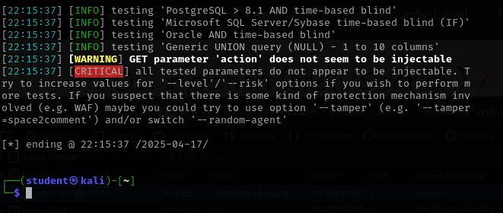

* It did not find the parameter to be injectable
* I attempted to add more parameters to sqlmap to help it, including:
  + -p movie 
  + --risk =3 --level=5 
  + --technique=U 

Adding any of these parameters to help sqlmap did not affect its results, and it still output that there was no injectable parameter. I did not believe that nothing could be injected here, but the purpose of bWAPP is to test for these vulnerabilities, so after some research, I found this YouTube video:

Source: <https://www.youtube.com/watch?v=3FxT_HZ2Z6k&t=17s&ab_channel=AungSanOo>

In this video, the man manually injects into the URL, showing that it is in fact injectable

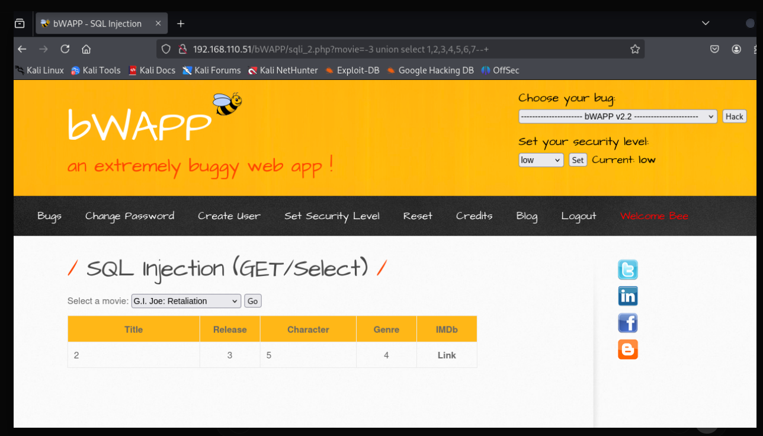

Using this knowledge from this video, I tried to implement it with sqlmap:

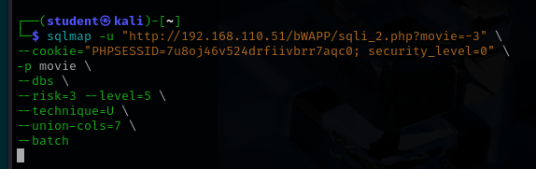

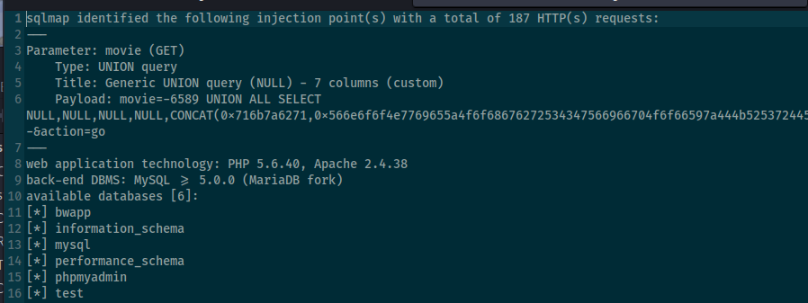

This was a key breakthrough. However, further attempts to extract tables from the bwapp database were unsuccessful. It was at this point that I decided to use Burp Suite to help aid sqlmap and give it all the information it needed.